# NETWORKING & SYSTEM ADMINISTRATION LAB

**Name: Stebin Babu**

**Roll No: 44**

**Batch: B**

**Date: 24/03/2022**

**Experiment No.: 3**

# Aim

Familiarization of the linux commands.

# Procedure

1. **pwd**

This command is used to display the location of the current working directory. Syntax :- $ pwd

Output :-



# mkdir

This command is used to create a new directory under any directory. Syntax :- $ mkdir <directory name>

Output :-

# ls

This command is used to display a list of content of directory. Syntax :- $ ls

Output :-

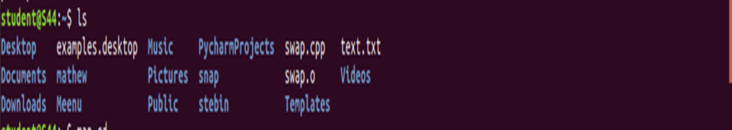

# man

This command is used to display the user manual of any command that we can run on the terminal.

Syntax :- $ man <command name> Output :-

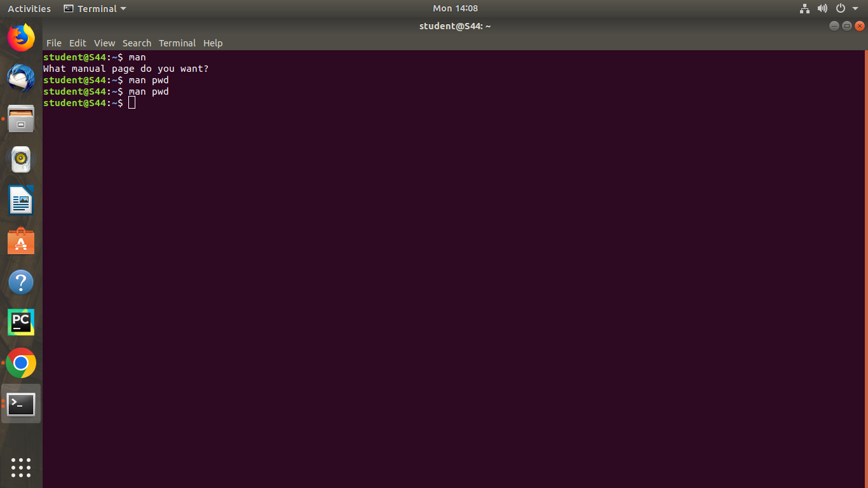

# ls –l

This command is used to shows file or directory, size, modified date and time, file or folder name and owner of the file, and its permission.

Syntax :- $ ls –l Output:-

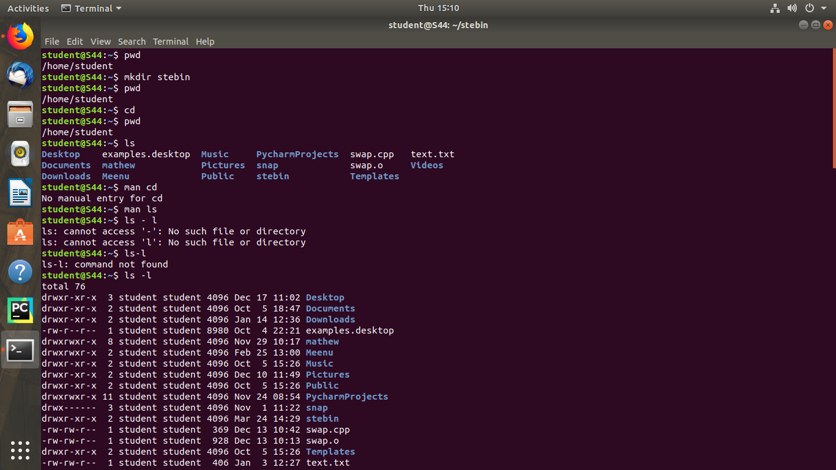

# ls –r

This command is used to display files and directories in reverse order

Syntax :- $ls –r

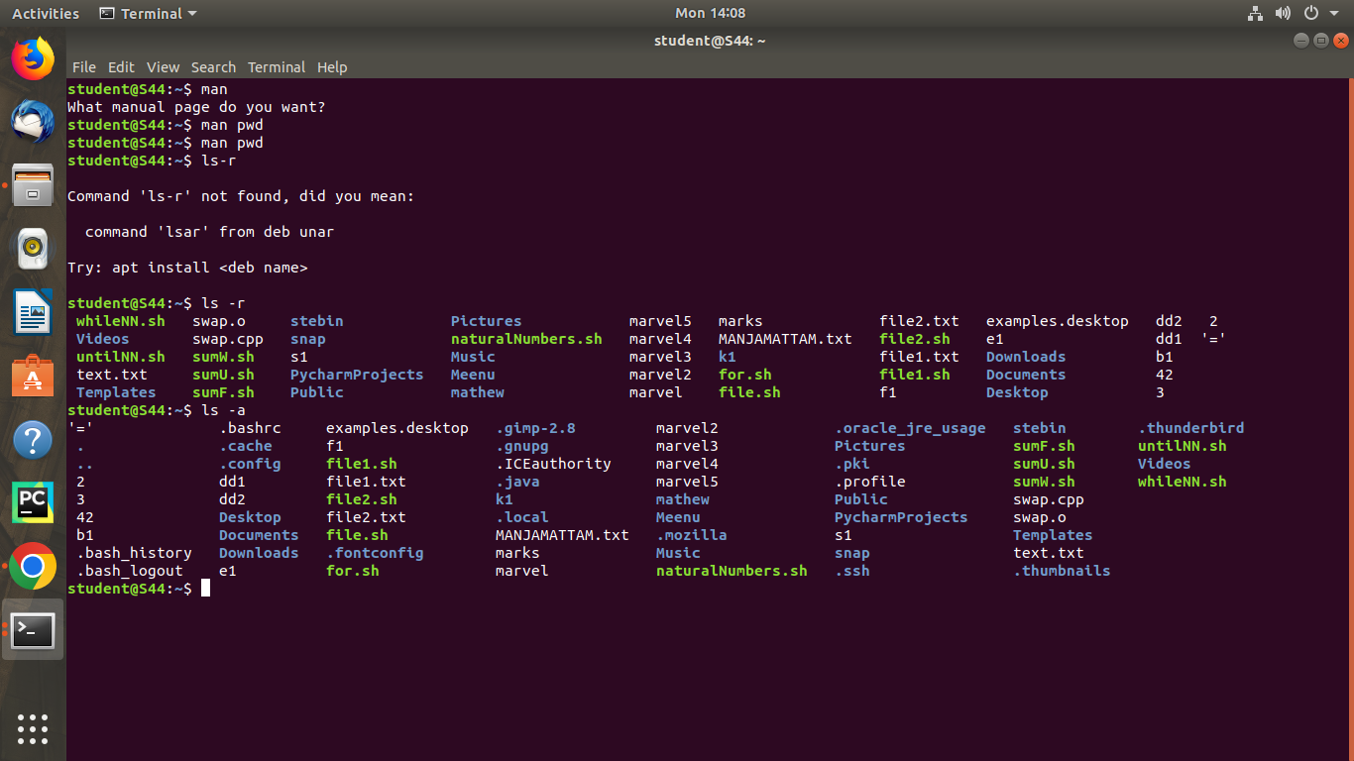 Output :-

# ls –a

This command is used to list all files including hidden files. Syntax :- $ls –a

Output :-



# ls –al

# This command is used to list all files including hidden files

Syntax :- $ ls -al Output :-

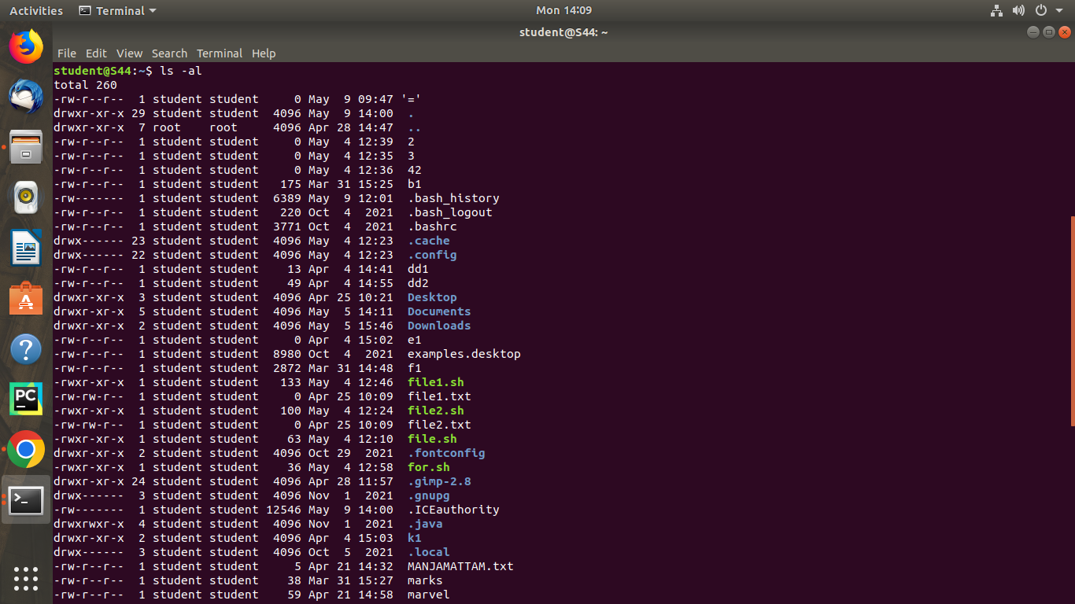

# ls –t

This command is used to display files in the last modified order. Syntax :- $ ls –t

Output :-

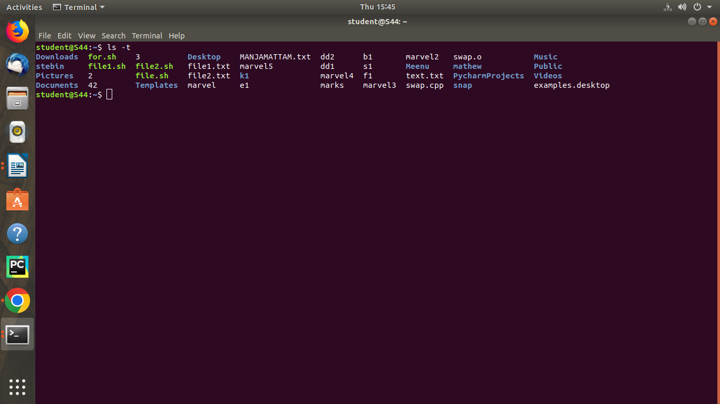

# cd

This command is used to change the current directory. Syntax :- $ cd <directory name>

Output :-

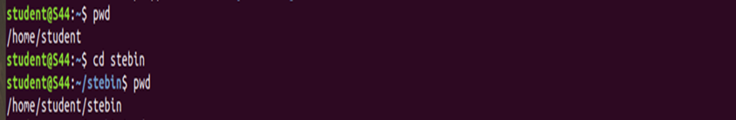

# cd ..

This command is used to move to the parent directory of current directory, or the directory one level up from the current directory.

Syntax :- $ cd ..

Output :-

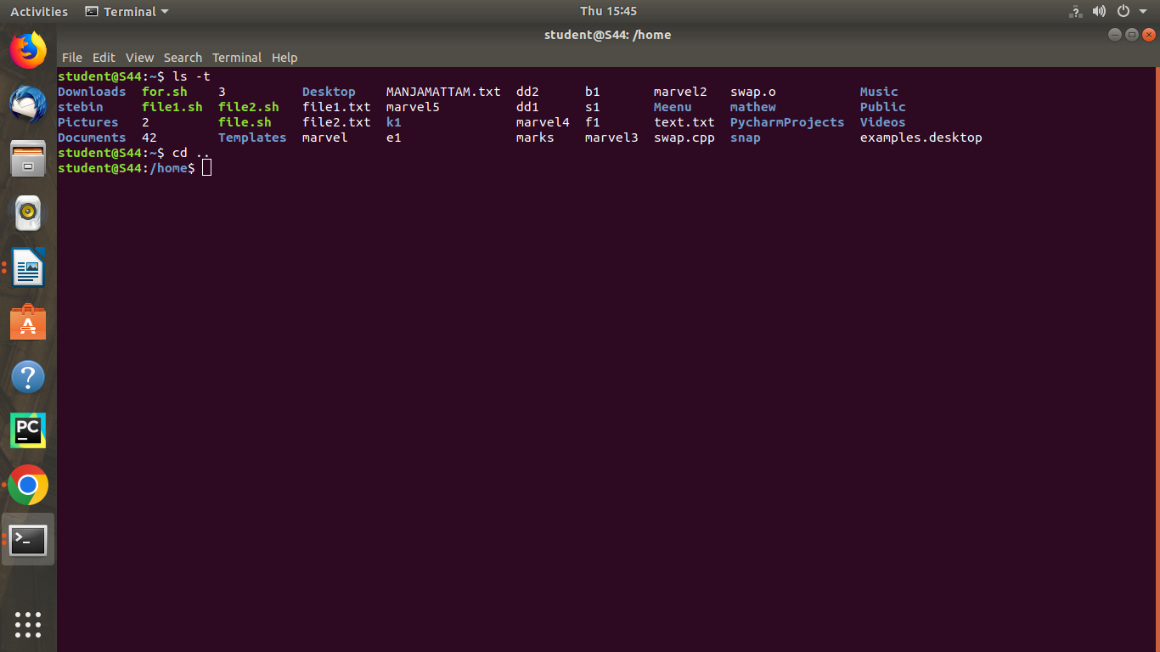

# cd –

This command is used to switch back to previous directory we were working earlier.

Syntax :- $ cd – Output :-

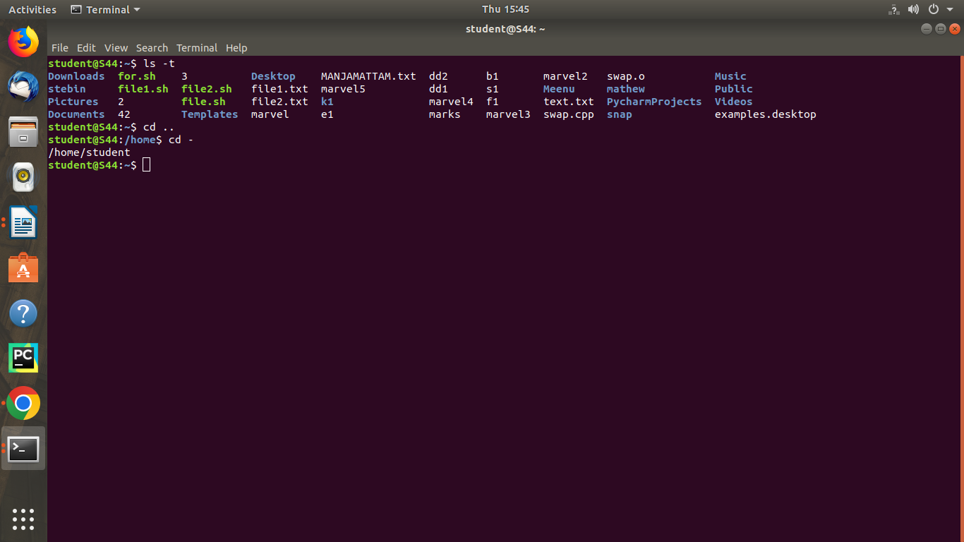

# cat > filename

This command is used to create a file and add contents to that file. Syntax :- $ cat > filename.txt

Output :-

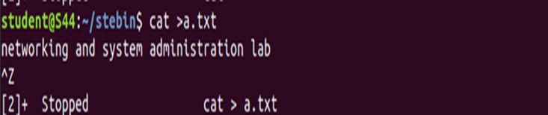

# cat>>filename

This command is used to add contents to an existing file. Syntax :- $ cat >> filename.txt

Output :-

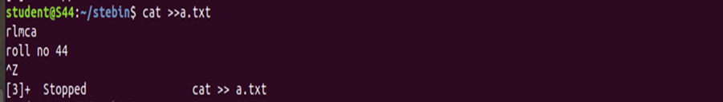

# cat filename

This command is used to view the contents in the file. Syntax :- $ cat filename.txt

Output :-

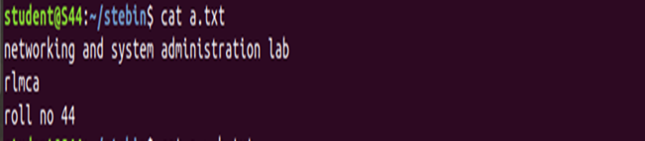

# cat filename1 > filename2

This command is used to copy the content from one file to another file. Syntax :- $ cat filename1 > filename2

Output :-

